- AQWA

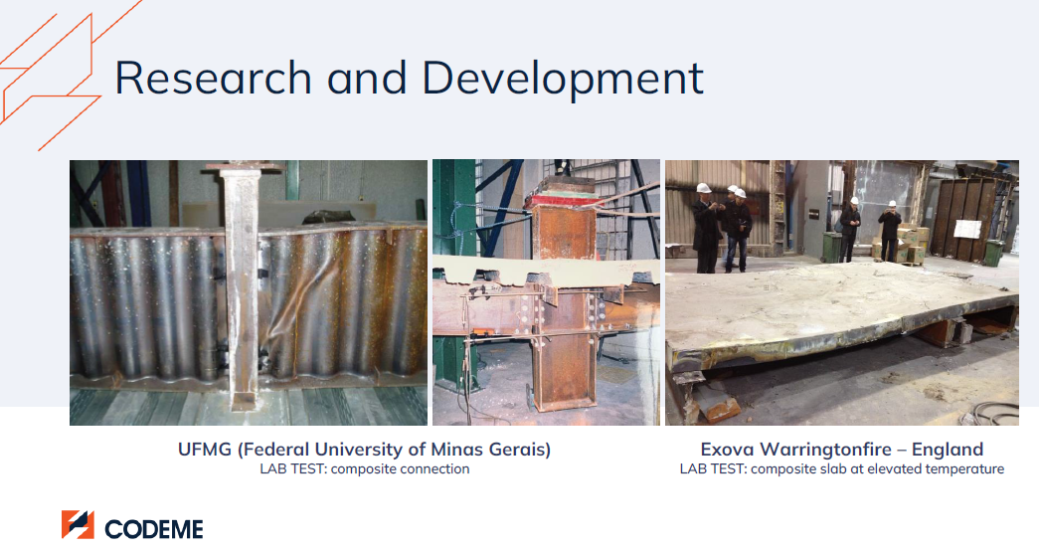
STRUCTURE: INNOVATIVE TESTS RELATED TO PERFORMANCE

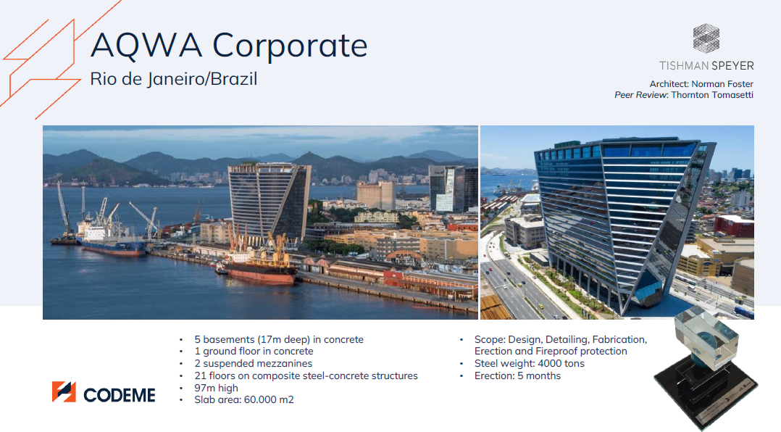
STRUCTURE: DETAILS (REAL AND ARCHITECTURE MODEL)

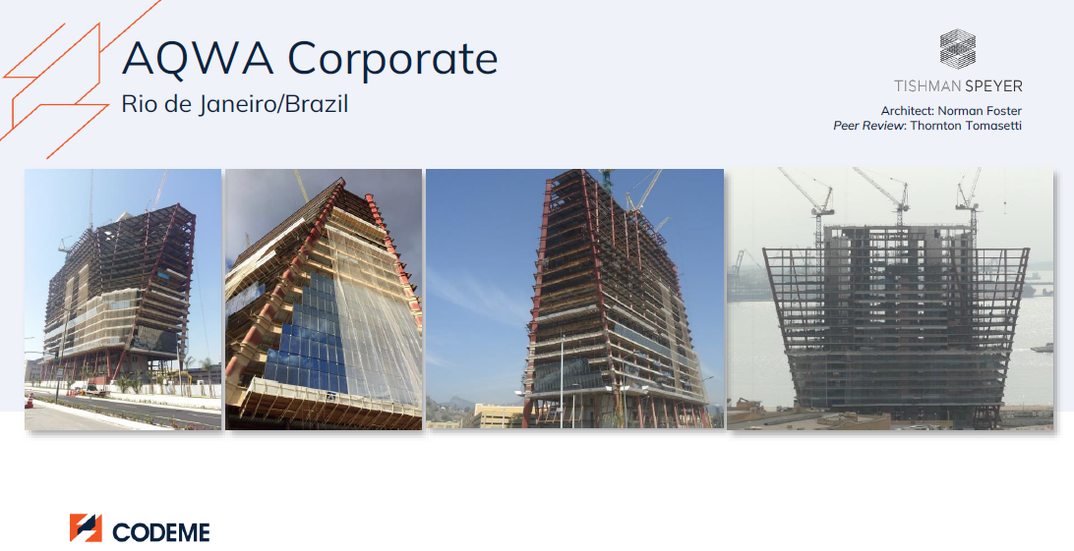
STRUCTURE: ERECTION PHASE

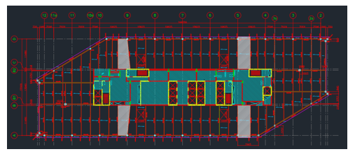
STRUCTURE: TYPICAL FLOOR

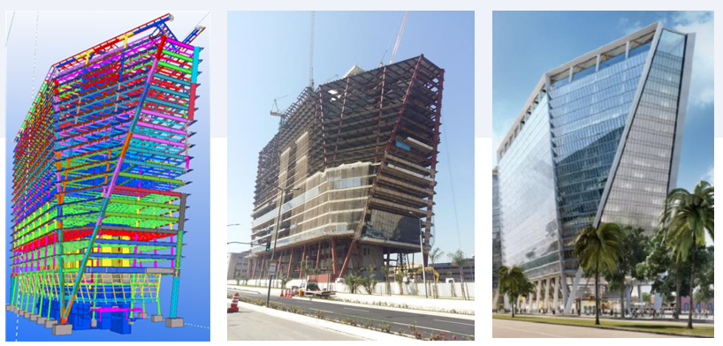
STRUCTURE: DETAILS (TEKLA MODEL, ERECTION PHASE AND ARCHITECTURAL MODEL)

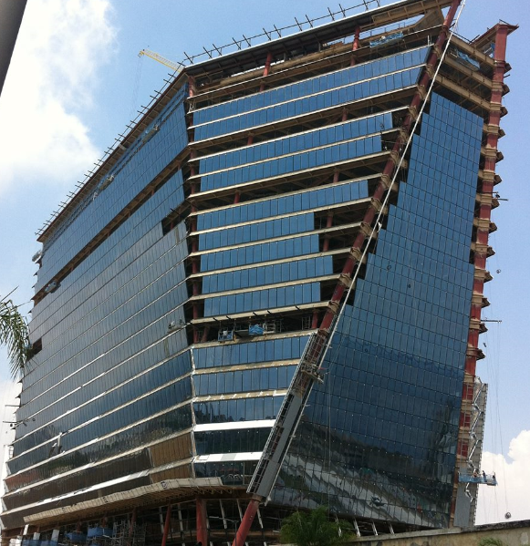
STRUCTURE: ERECTION PHASE

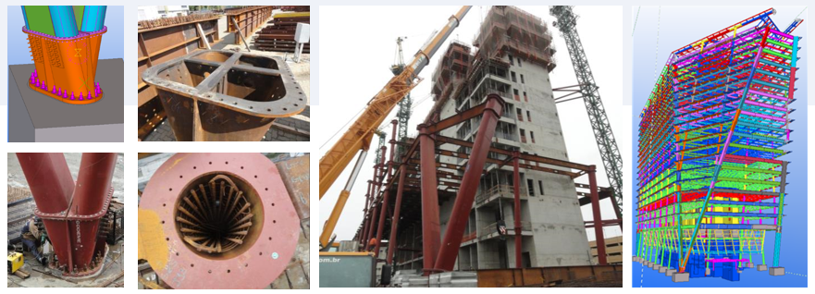
STRUCTURE: DETAILS (FEM & REAL INNOVATIVE CONNECTIONS AND TEKLA MODEL)

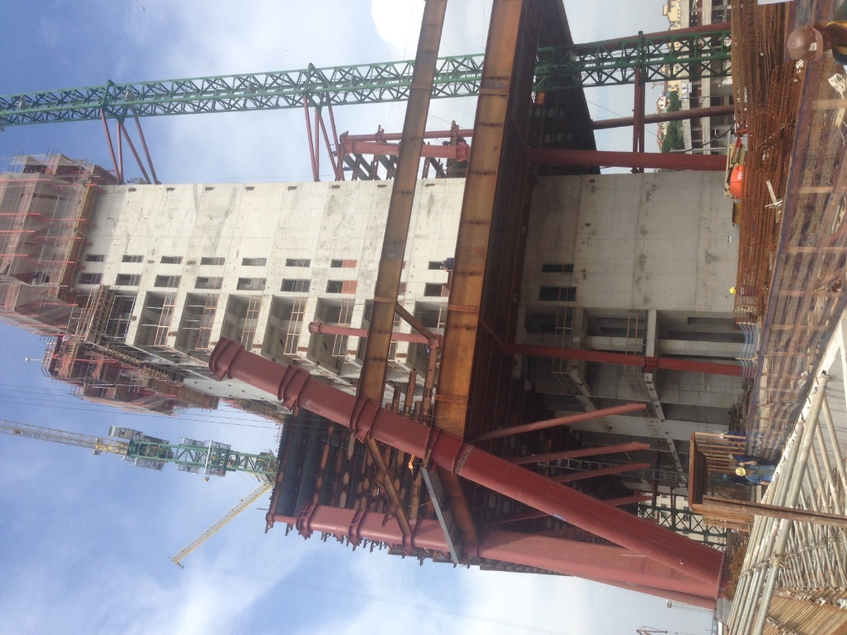
STRUCTURE: ERECTION PHASE

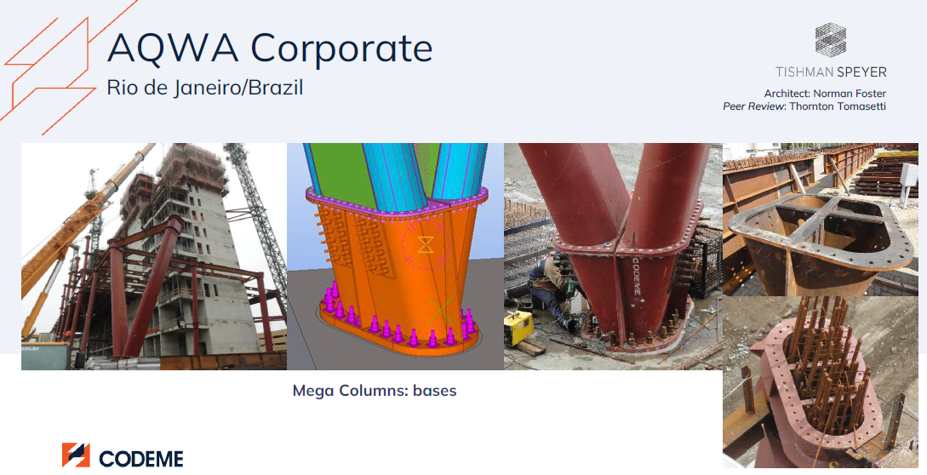
STRUCTURE: DETAILS (FEM % REAL INNOVATIVE CONNECTIONS AND TEKLA MODEL)

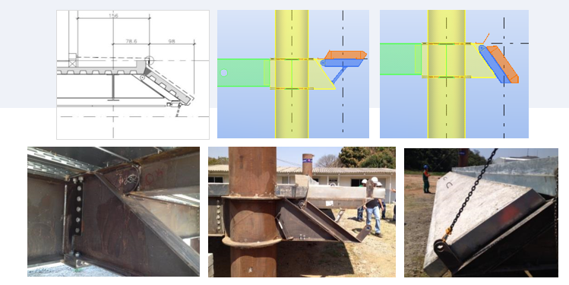
STRUCTURE: DETAILS (FEM % REAL CONNECTIONS AND TEKLA MODEL)

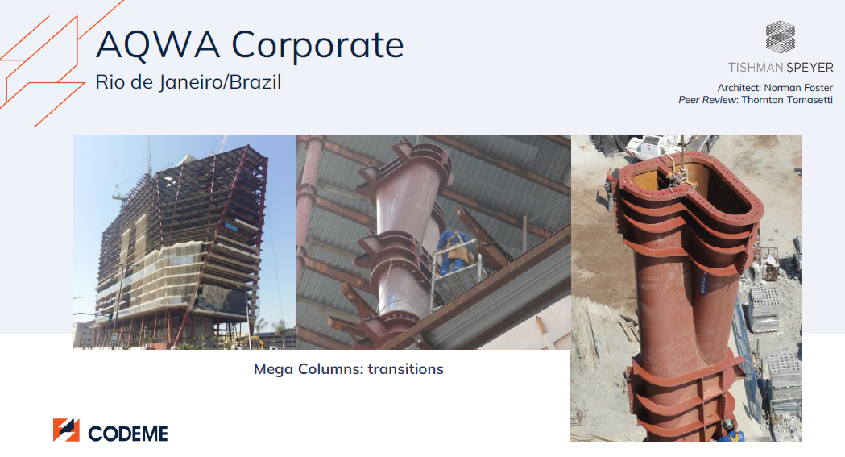
STRUCTURE: DETAILS (REAL CONNECTIONS)

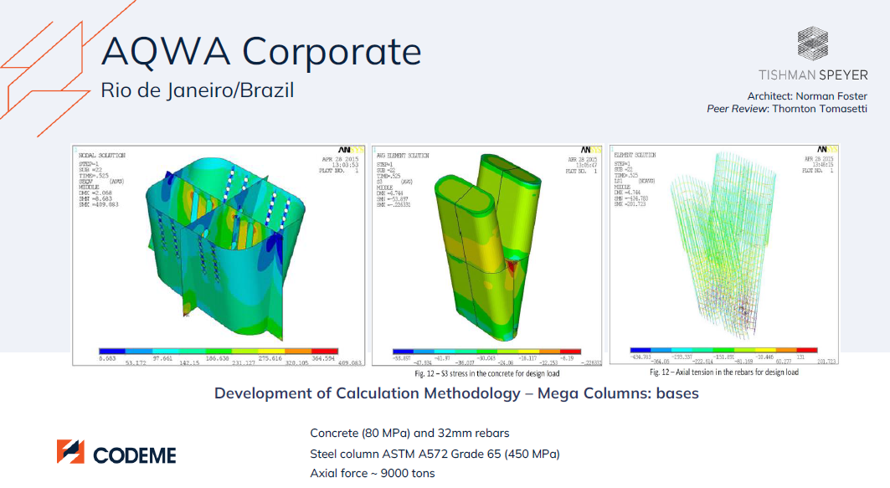
STRUCTURE: DETAILS (INNOVATIVE FEM CONNECTIONS)

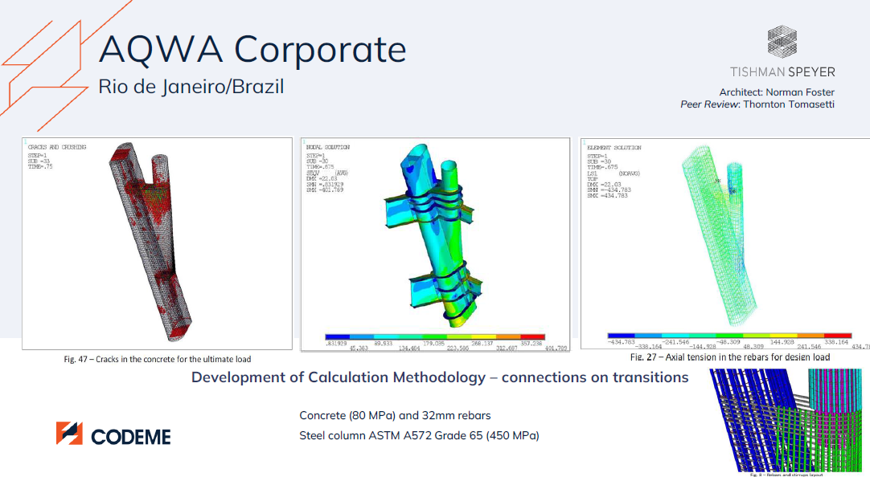
STRUCTURE: DETAILS (INNOVATIVE FEM CONNECTIONS AND TEKLA MODEL)

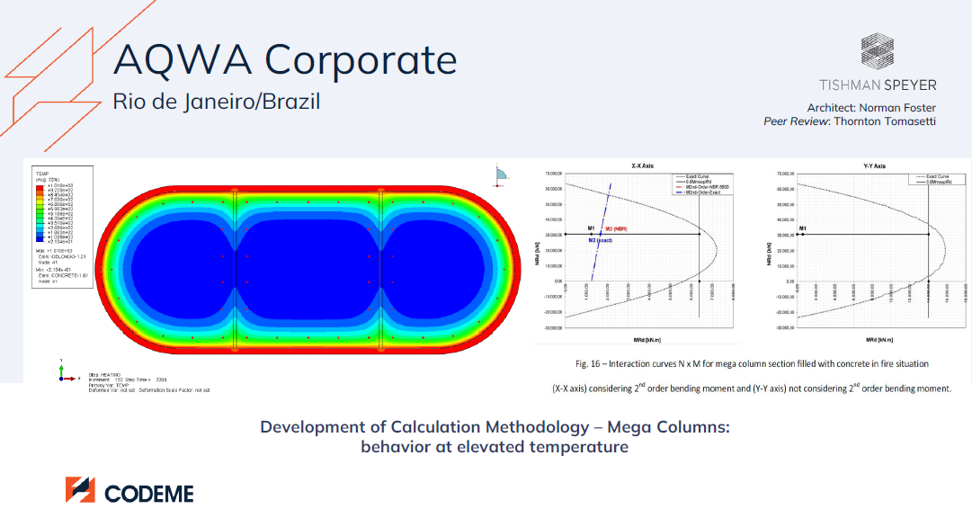
STRUCTURE: DETAILS (CONNECTIONS DESIGN)

