- CONCÓRDIA

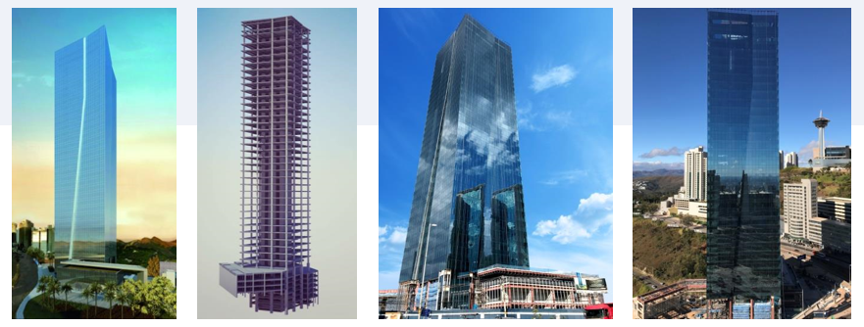
STRUCTURE: DETAILS (REAL AND TEKLA MODEL)

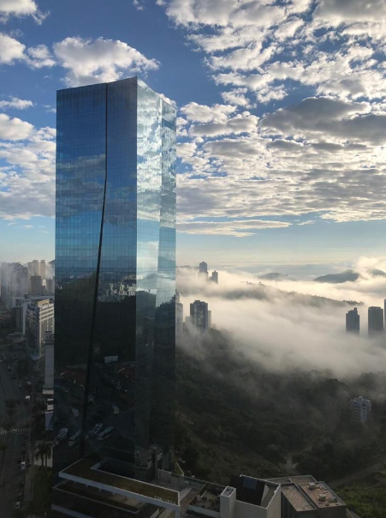
STRUCTURE: DETAILS (REAL)

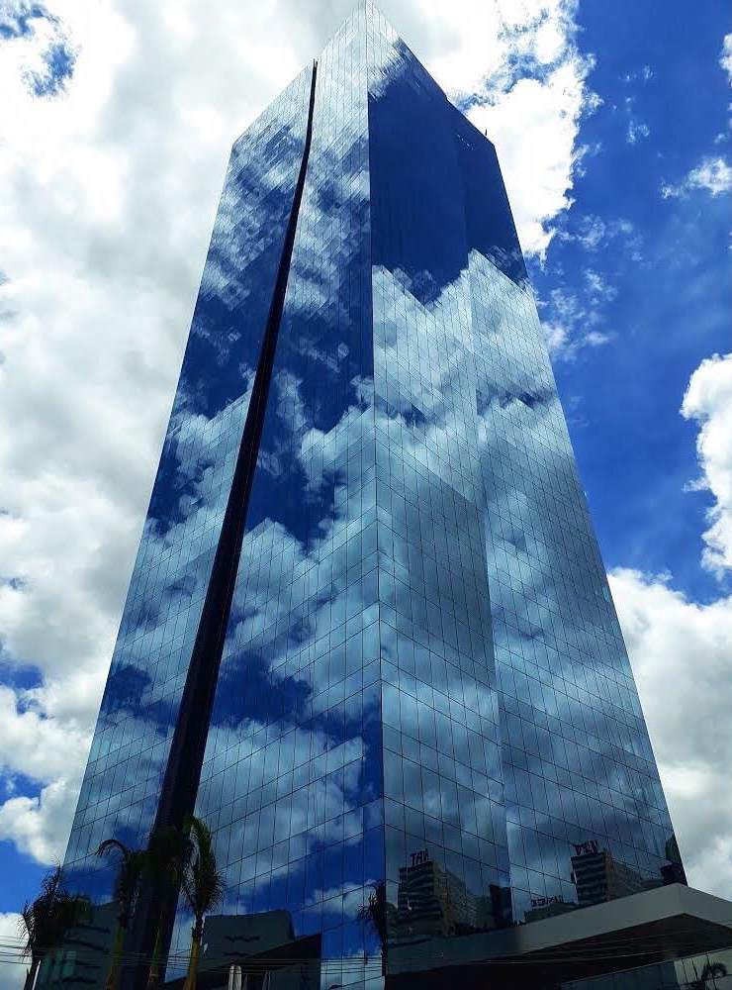
STRUCTURE: DETAILS (REAL)

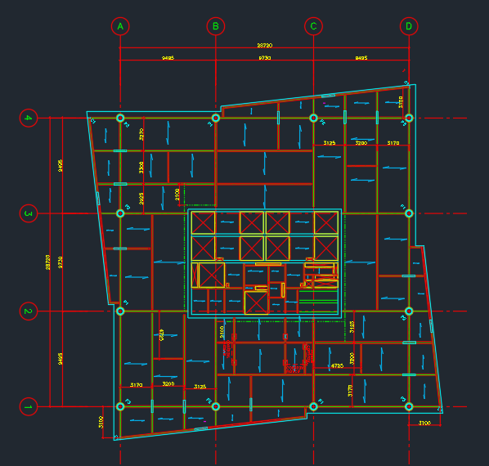
STRUCTURE: TYPICAL FLOOR

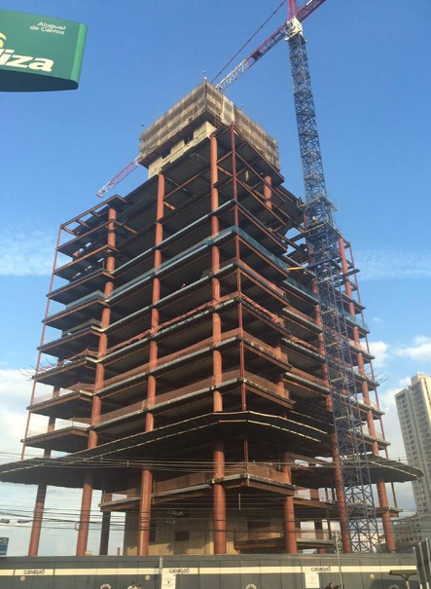
STRUCTURE: ERECTION PHASE

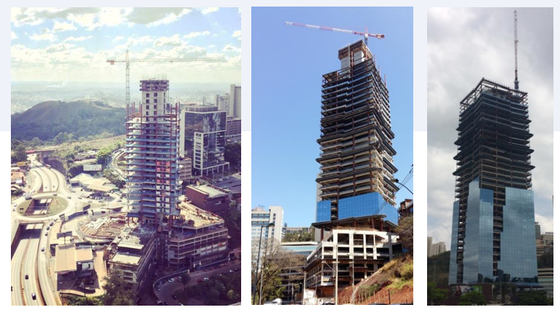
STRUCTURE: ERECTION PHASE

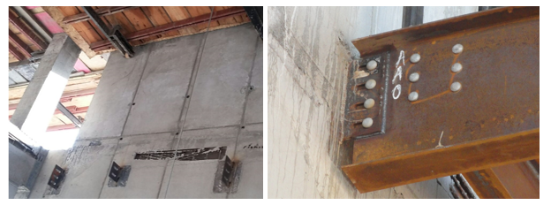
STRUCTURE: DETAILS (REAL)

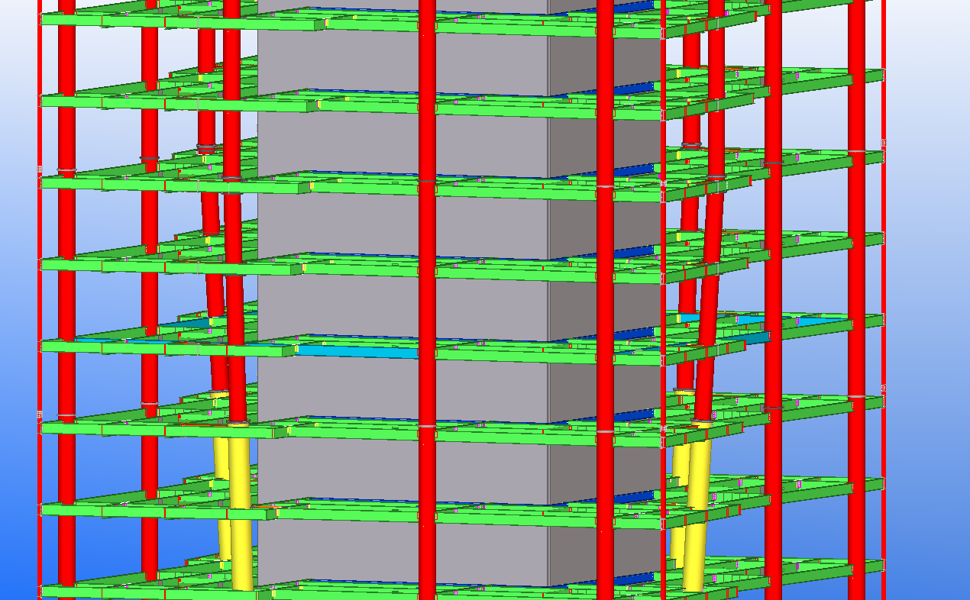
STRUCTURE: DETAILS (TEKLA MODEL)

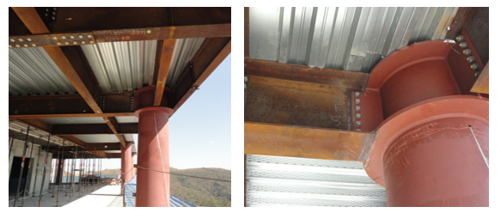
STRUCTURE: DETAILS (REAL)

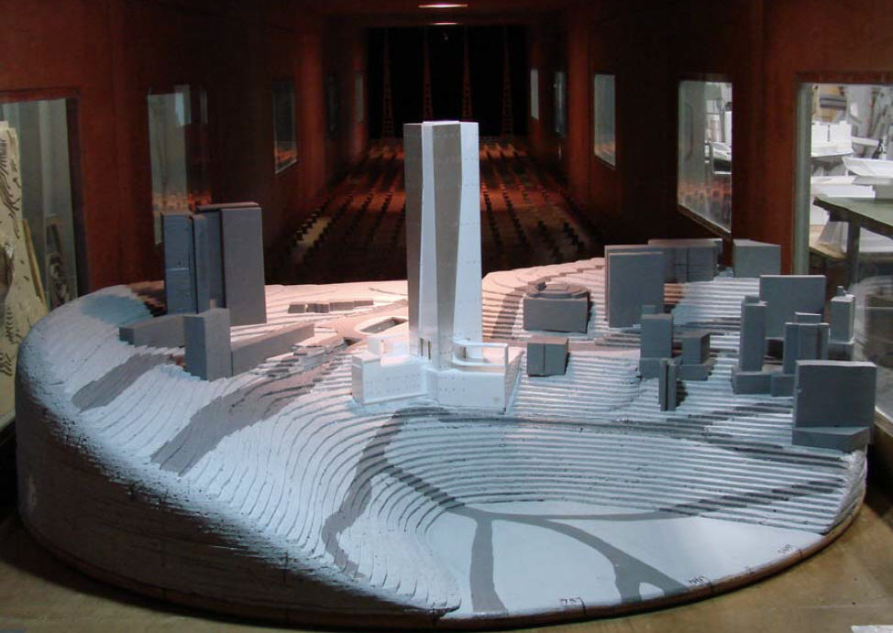
WIND TUNNEL

