- ARENA MRV

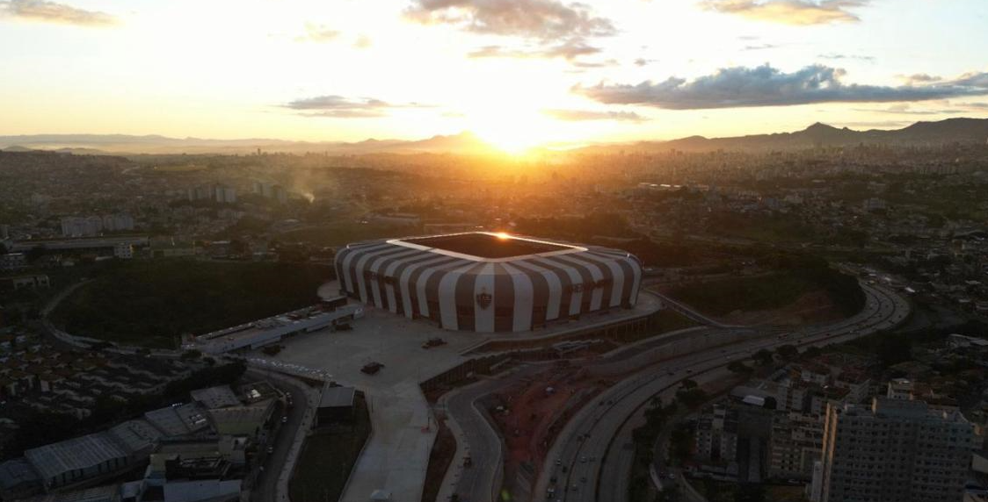
ARCHITECTURE MODEL

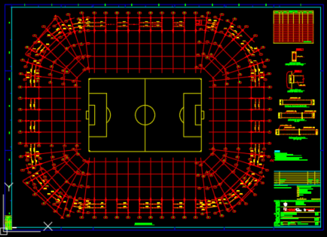
STRUCTURE: TYPICAL FLOOR (PLANT)

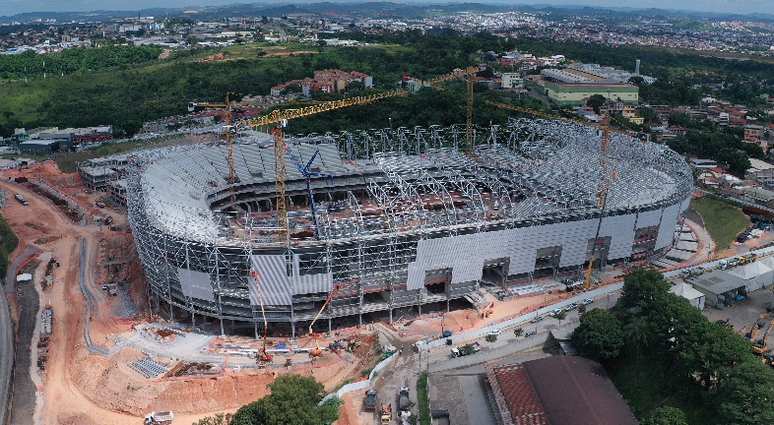
STRUCTURE: ERECTION PHASE

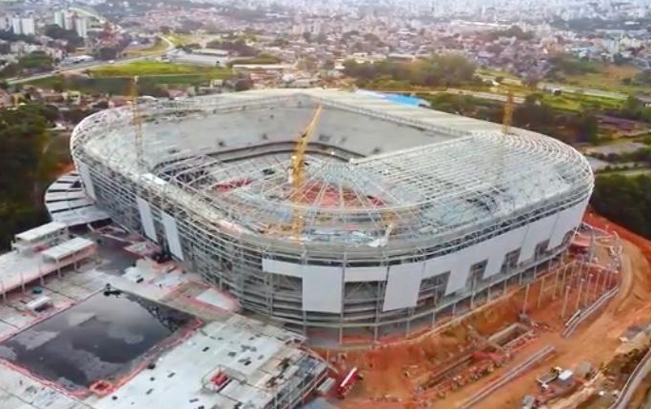
STRUCTURE: ERECTION PHASE

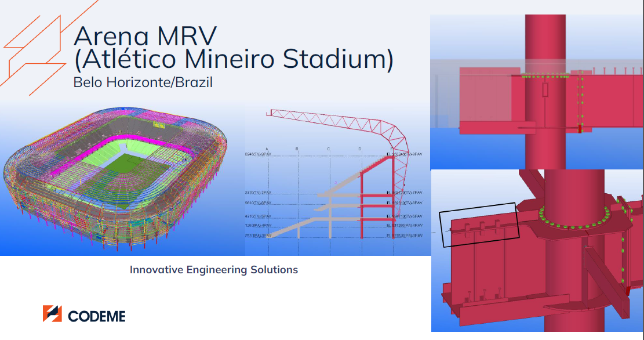
STRUCTURE: DETAILS (INNOVATIVE FEM CONNECTIONS – STEEL / PRESSTRESSED CONCRETE - AND TEKLA MODEL)

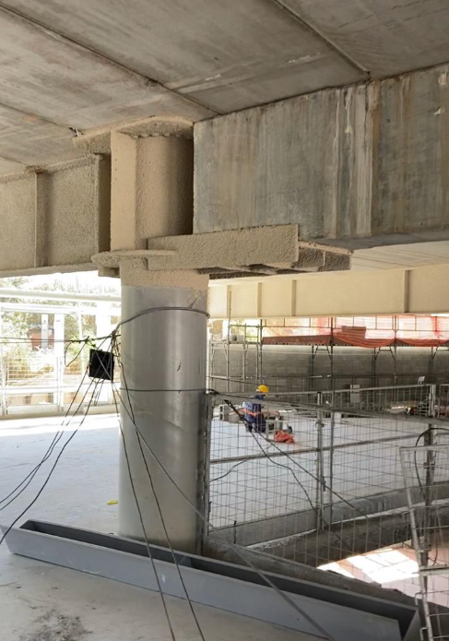
STRUCTURE: DETAILS (INNOVATIVE CONNECTIONS – REAL STRUCTURE: STEEL / PRESSTRESSED CONCRETE)

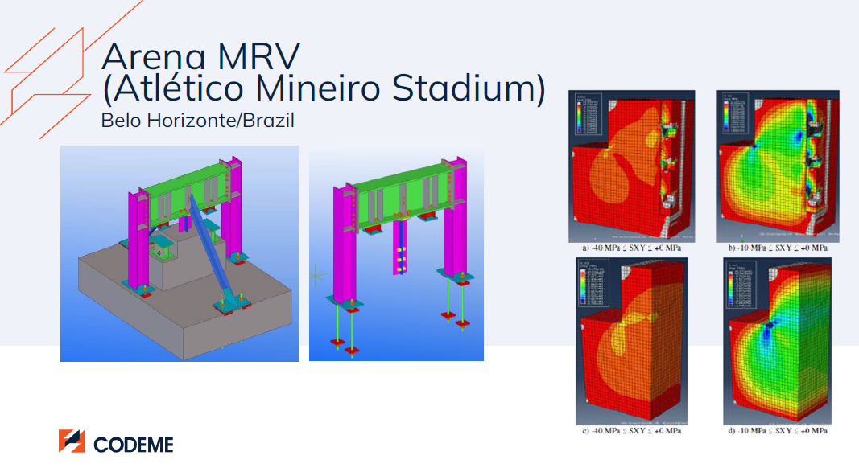
STRUCTURE: DETAILS (INNOVATIVE FEM CONNECTIONS – STEEL / PRESSTRESSED CONCRETE - AND TEKLA MODEL)

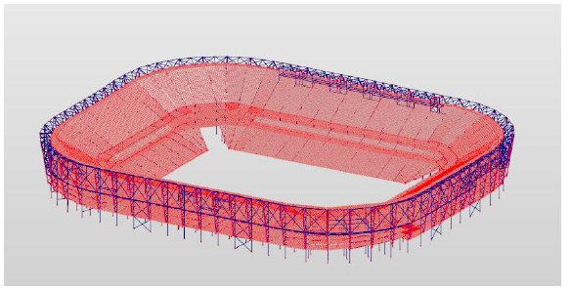
STRUCTURE: DETAILS (ROBOT AUTODESK STRUCTURE MODEL)

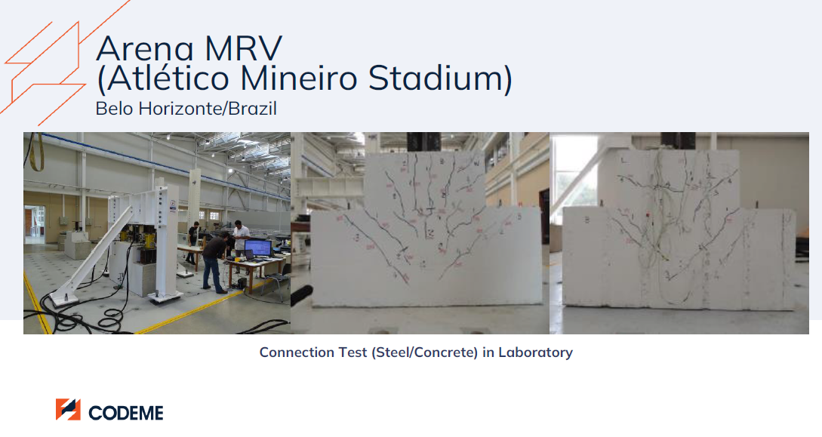
STRUCTURE: DETAILS (INNOVATIVE FEM CONNECTIONS – STEEL / PRESSTRESSED CONCRETE)

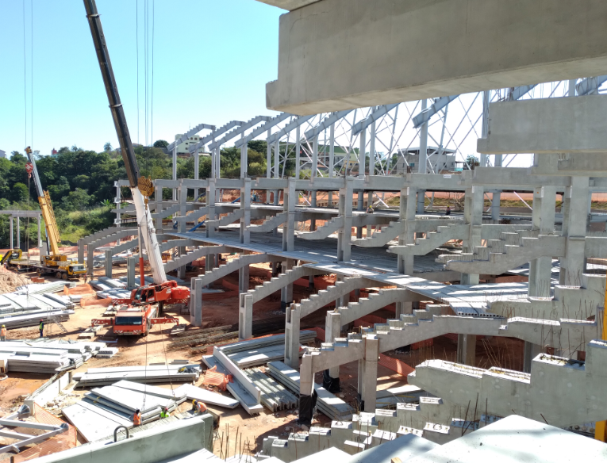
STRUCTURE: DETAILS (REAL: STEEL / PRESSTRESSED CONCRETE)

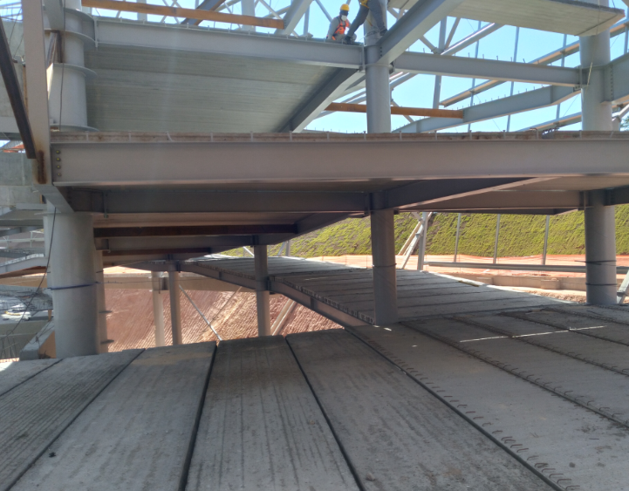
STRUCTURE: DETAILS (REAL: STEEL / PRESSTRESSED CONCRETE HOLLOW-CORE SLABS)

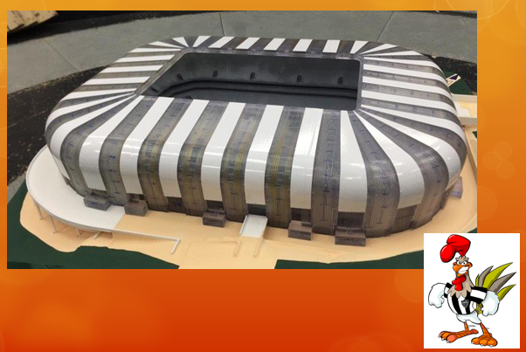
WIND TUNNEL

