- BS DESIGN

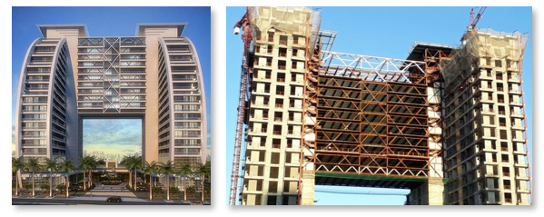
STRUCTURE: DETAILS (ARCHITECTURE MODEL AND REAL)

