- TAGUATINGA SHOPPING

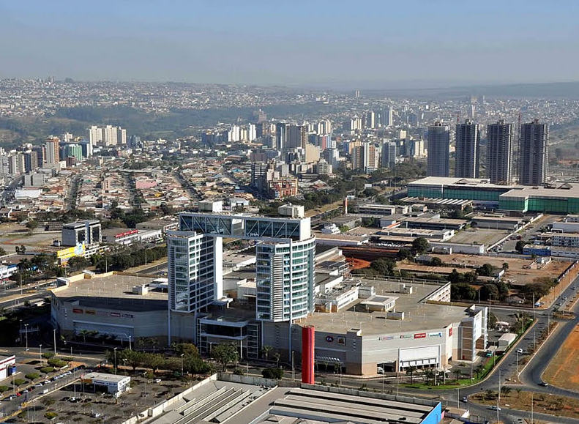
STRUCTURE: DETAILS (REAL)

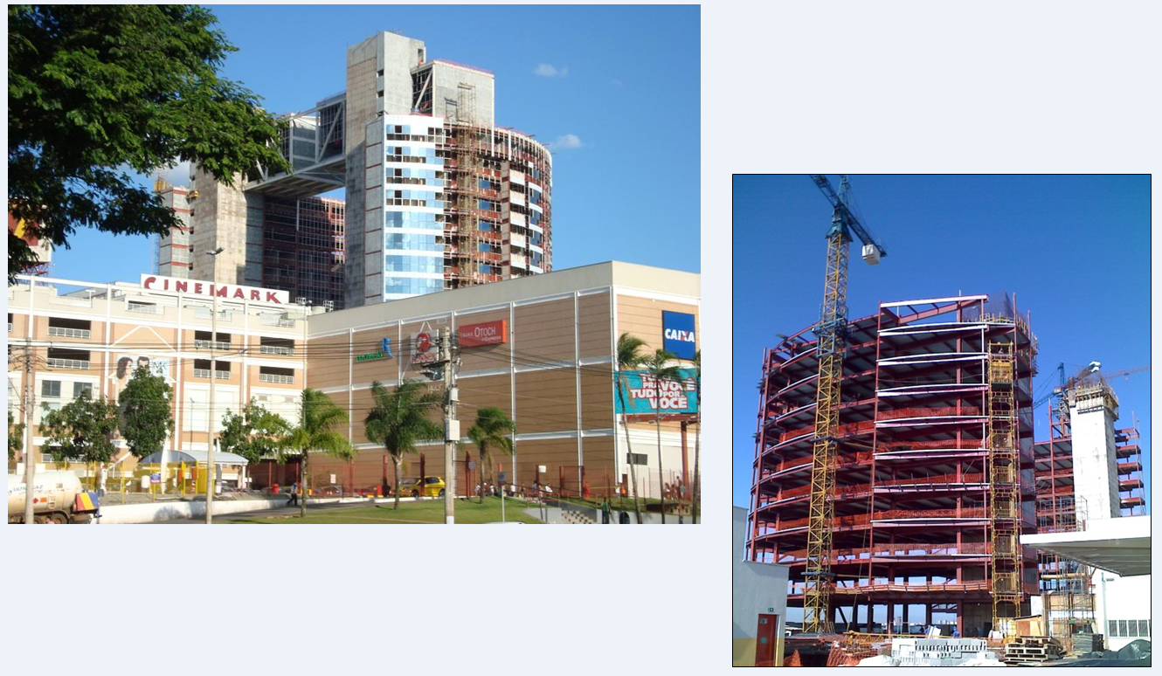
STRUCTURE: DETAILS (REAL)

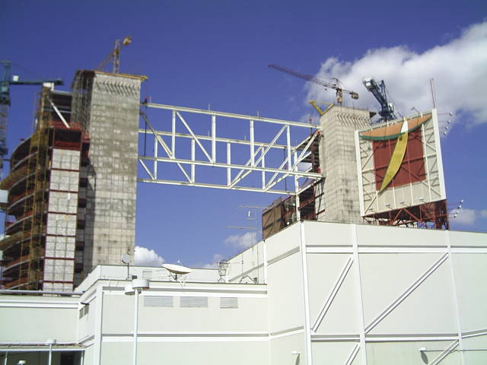
STRUCTURE: ERECTION PHASE

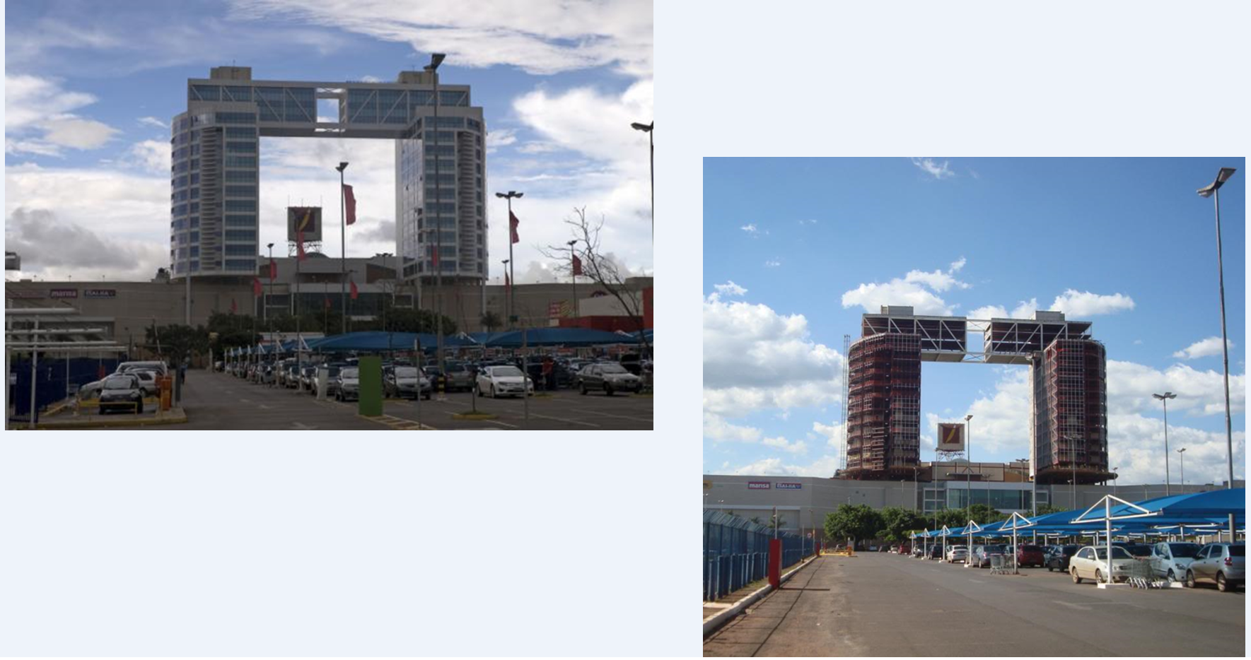
STRUCTURE: REAL AND ERECTION PHASE

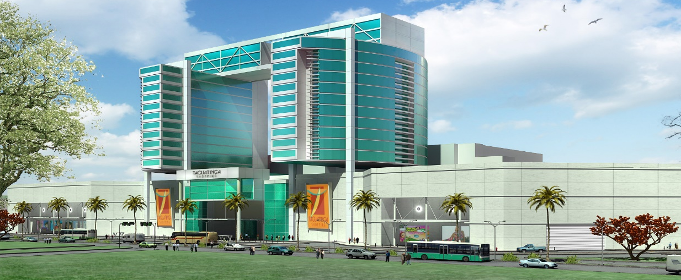
STRUCTURE: DETAILS (ARCHITECTURE MODEL)

